

“SARCASM DETECTION”

A Project Report Submitted to

Gujarat Technological University in Fulfillment of the Requirements for the Degree of

Bachelor of Engineering

In

Information Technology

**B. E., Semester –VIII**

**By**

**Group ID: GC_IT_MPP_U6**

**Nihar Patel**

**Pooja Suthar**

**Enrollment No. 160110116033**

**Enrollment No. 160110116051**

**Faculty Guide**

**Dr. Miral Patel**

**[Associate Professor (IT)]**



**Academic Year 2019-20**

**Department of Information Technology**

**G H Patel College of Engineering & Technology**

**Vallabh Vidyanagar, Anand**

**i**

**Acknowledgment**

We would like to express our gratitude and appreciation to all those who gave us the incentive to work on this project. A special thanks to our project guide, **Dr. Miral Patel**, whose presence, stimulating suggestions and encouragement, helped us to coordinate our project.

Hereby, we would also like to acknowledge with much reverence the crucial role of our department, who were supportive and provided us with all the possible assistance as and when required.

Moreover, we are thankful to the Head of the Department (Information Technology), **Dr.** **Nikhil Gondaliya**, who has given his unmatched guidance in achieving the goal as well as hismotivation to maintain our project's progress in track. Last but not the least, the involvement of the panels during every single presentation helped us vivify our vision for this project, their straight-forwardness and concise comments aided our ambition in making of this project.

ii

**COLLEGE CERTIFICATE**

**Date:**

This is to certify that the project entitled “**SARCASM DETECTION**” has been carried out byNIHAR PATEL (160110116033) and POOJA SUTHAR (160110116051) under my guidance in partial fulfillment for the degree of Bachelor of Engineering in Information Technology (7th Semester) of Gujarat Technological University, Ahmedabad during the academic year 2019-20



|  |  |
| --- | --- |
| Internal Guide | Head of Department |
| Dr. Miral Patel | Dr. Nikhil Gondaliya |
| Associate Professor (IT) | Head & Professor (IT) |

iii

## ABSTRACT

One of the consequences of the unabated growth of social media has been a surge in the production of opinionated user-generated content. This data represents an immensely valuable resource if meaningful insights and trends can be accurately extracted.

With the growth of the web, micro blogs such as Twitter are becoming popular day by day. People use Twitter for sharing information and opinions on a variety of topics and to discuss current issues. A lot of companies have had a keen attraction towards this data, especially to analyze opinions of people concerning various genres like movies, songs, political events, reviews on products etc. Thus, understanding the opinion of the individuals is needed.

Sentiment analysis is the field of study that analyses people's sentiments, attitudes, and emotions from text. It is one of the most active research areas widely studied in data mining, Web mining, and text mining.

Sentiment analysis can be easily misled by the presence of words that have a strong polarity but are used sarcastically, which means that the opposite polarity was intended

One of the challenges facing sentiment analysis, the field of research that addresses this task, is the accurate detection of sarcasm, which flips the polarity of literally interpreted sentiments.

Sarcasm is a form of speech act in which the speakers convey their message in an implicit way. The inherently ambiguous nature of sarcasm sometimes makes it hard even for humans to decide whether an utterance is sarcastic or not. Unlike a simple negation, a sarcastic sentence conveys a negative opinion using only positive words or intensified positive words.

The detection of sarcasm is therefore important, for the development and refinement of Sentiment Analysis.

iv

**LISTS OF FIGURES**

|  |  |  |
| --- | --- | --- |
| **Figure No.** | **Figure Name** | **Page No.** |
| 2.1 | Proposed Business canvas……………………………... | 2 |
| 2.2 | Key Partners………………………………………........ | 3 |
| 2.3 | Key Activities………………………………………….. | 3 |
| 2.4 | Value Proposition…………...………………………….. | 4 |
| 2.5 | Key Resources ….……….……………………………... | 5 |
| 2.6 | Customer Relationship………………………………….. | 5 |
| 2.7 | Customer Segments…………………………………….. | 6 |
| 2.8 | Channel ……………………………………………….. | 6 |
| 2.9 | Cost Structure………………………………………….. | 7 |
| 2.10 | Revenue Stream………………………………………… | 7 |
|  |  |  |

v

**TABLE OF CONTENTS**

|  |  |  |
| --- | --- | --- |
| **Sr** | **Topic** | **Page No.** |
| **No.** |  |  |
|  | **List of Figures…………………………....……………………** | v |
|  | **Table of Contents……………………………………………..** | vi |
| **1** | **Introduction…………………………………………………...** | 2 |
| **2** | **Contents……………………….………………………………..** |  |
|  | 2.1 Proposed Business Canvas…………………………………. | 2 |
|  | 2.2 Key Partners…..…...…………………………....................... | 3 |
|  | 2.3 Key Activities……………………………………………... | 3 |
|  | 2.4 Value Proposition…………………..................................... | 4 |
|  | 2.5 Key Resources …....……………………………………….. | 5 |
|  | 2.6 Customer Relationship….………….…….……………….. | 5 |
|  | 2.7 Customer Segments....…………………………………….. | 6 |
|  | 2.8 Channel …….….………………………................................ | 6 |
|  | 2.9 Cost Structure ……………………………………………………. | 7 |
|  | 2.10 Revenue Stream…………………………………………………………….. | 7 |
| **3** | **Conclusion………………………………………………………..** | 8 |
|  |  |  |

vi



“SARCASM DETECTION”

A Business Model Canvas Report

*Submitted By*

Nihar Patel

Pooja Suthar

Enrollment No.160110116033

Enrollment No.160110116051

*In fulfilment for the award of the degree*

*Of*

**BACHELOR OF ENGINEERING**

In **Information Technology**



Semester 8th (4th year)

Academic Year 2019-20

Department of Information Technology

**G H Patel College of Engineering & Technology**

**Vallabh Vidyanagar, Gujarat**

**GUJARAT TECHNOLOGICAL UNIVERSITY**

**AHMEDABAD**

**October 2019**

**CHAPTER: 1**

**INTRODUCTION**

* 1. **Introduction**

Thus business model canvas can be used to visualize such customer expectations and market problems. This exercise will increase the market strategy and implementation of technology. This will make them more effective in market.

This exercise brings discussions on viability and cost effectiveness into picture with their impact. This exercise will enable us to have knowledge on the steps required to ensure that a solution they develop via project should have a user who can afford it with desired needs.

This exercise helps us to understand the true value of the proposed solution.

Business Model Canvas is used to validate the market significance of products and services which will be of technology nature in this case. Technology projects are often solutions or processes that solve a technical problem. However the market implementation of such solutions also require that the problem solution is designed to overcome not just the technical barriers but also market and business related barriers of costs, customer reach and collaborations and those that pertain to the practical nature of limited initial capacities within the team.

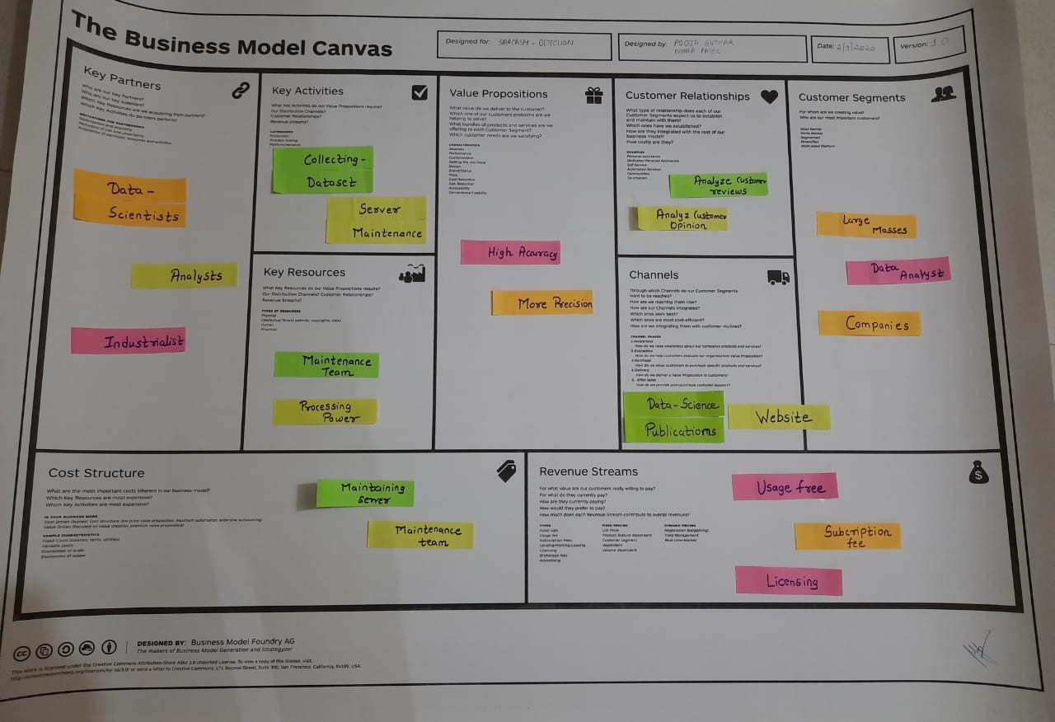

**Figure I Proposed Business Model Canvas**

2

**CHAPTER: 2**

**CONTENTS**

1. **KEY PARTNERS**

In this we can do partnership with different companies according to our product. By doing this we can get the idea about what is market scenario, optimization in product and cost can be achieved, from where we can get the raw material of our product.

* Analysts
* Industrialists
* Data Scientists

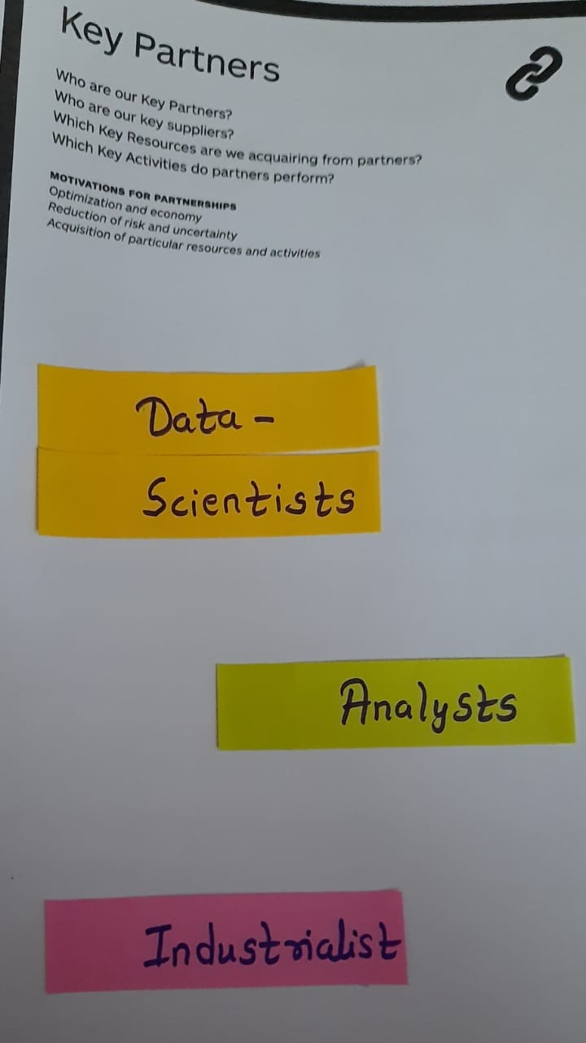

Figure III Key Partners

1. **KEY ACTIVITY**

In this we are made aware about how will they represent their product to customers. They can use the following for marketing of the product.

* Collecting Data set
* Server maintenance

3

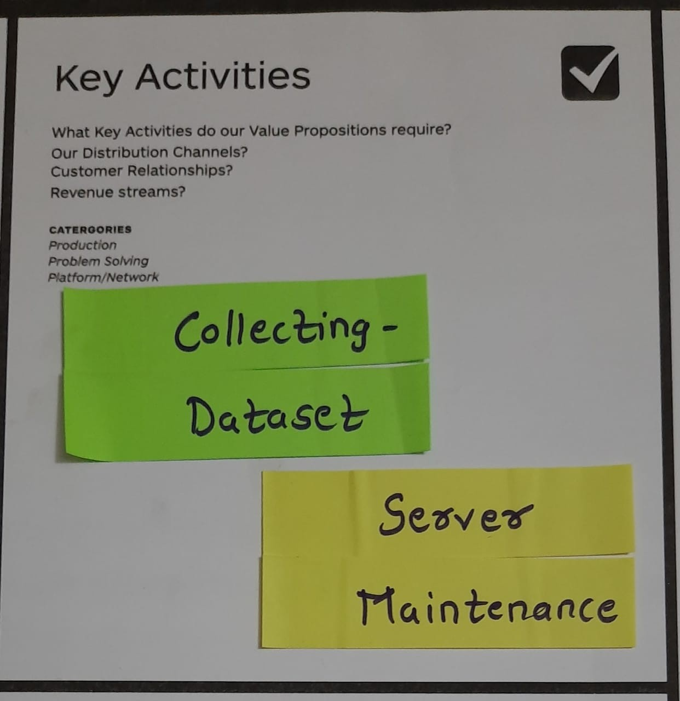

Figure IV Key Activities

1. **VALUE PROPOSITION**

In this one can directly come in contact with customer requirement. In this they will aware the customer about their product. How it is usable and beneficial over the conventional product and which kind of services they will provide to customers.

* High Precision
* 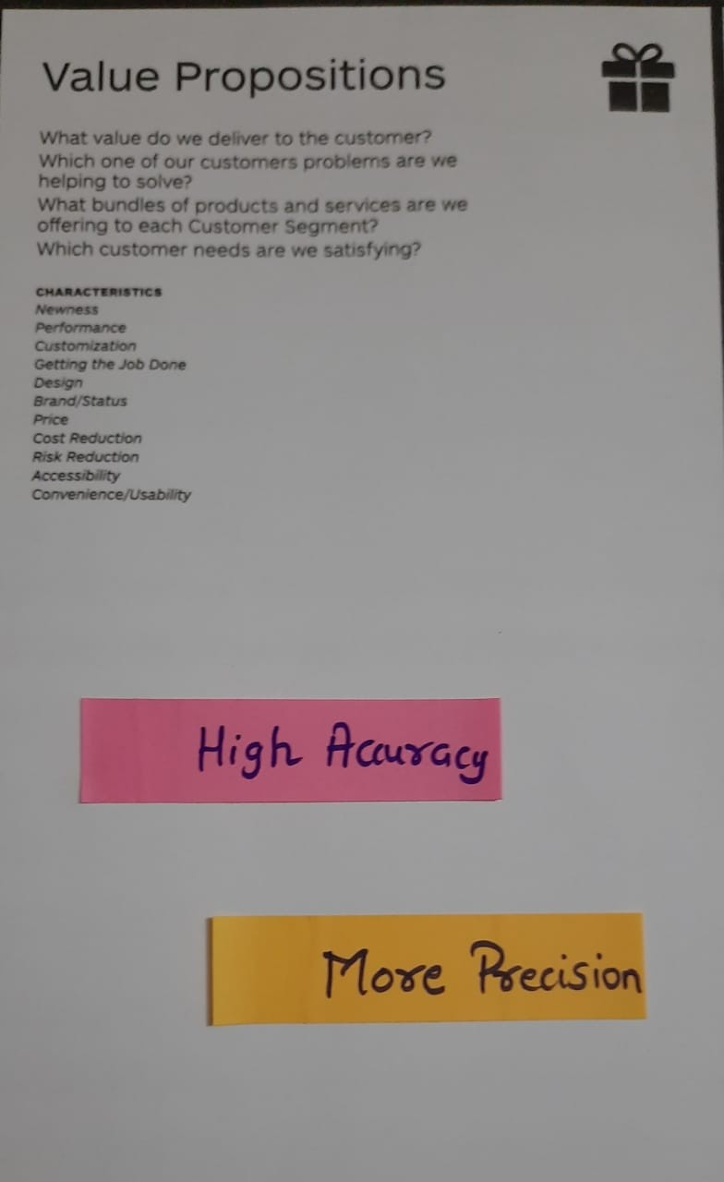More Accuracy

Figure V Value Proposition

4

1. **KEY RESOURCES**

In this section we can get idea about, from which kind of industries, they will purchase raw material for their product.

* Maintenance Team
* Processing Power

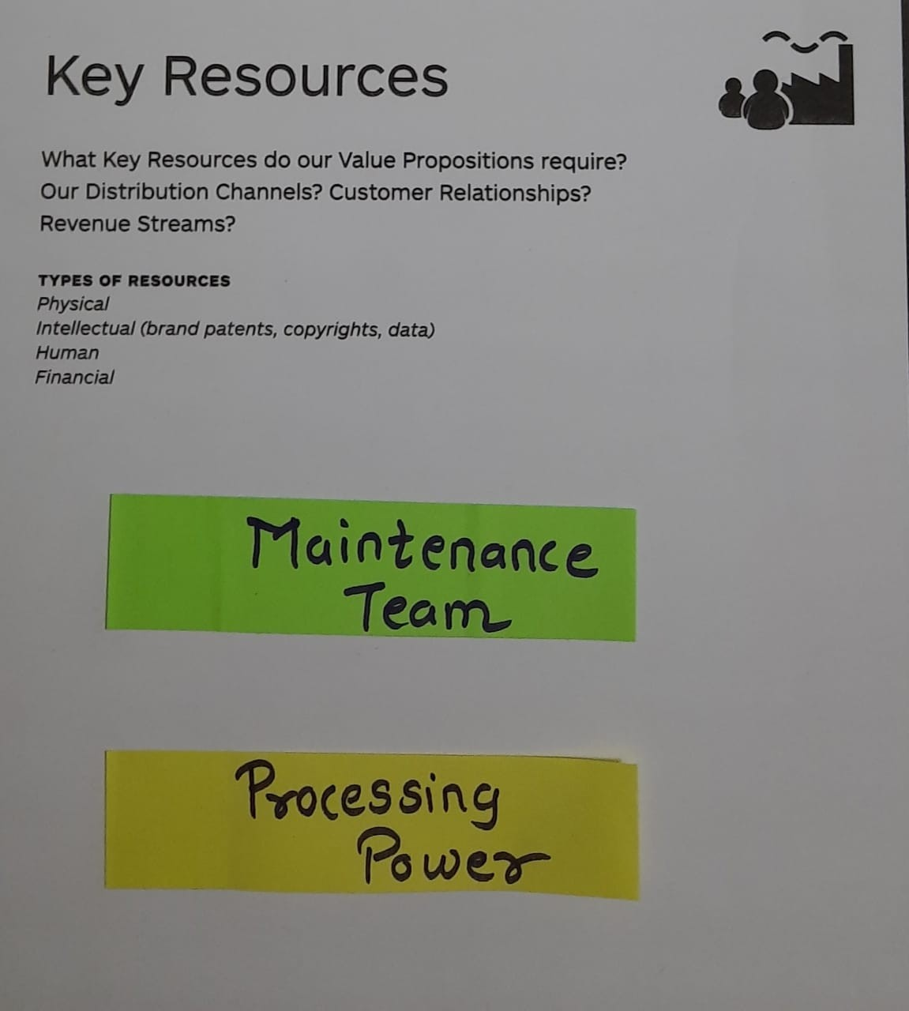

Figure VI Key Resources

#### **CUSTOMER RELATIONSHIP**

In this section we get to know about how they will manage the relationship with customer by giving them lucrative services.

* Analyse Customer Opinion
* Analyse Customer Review

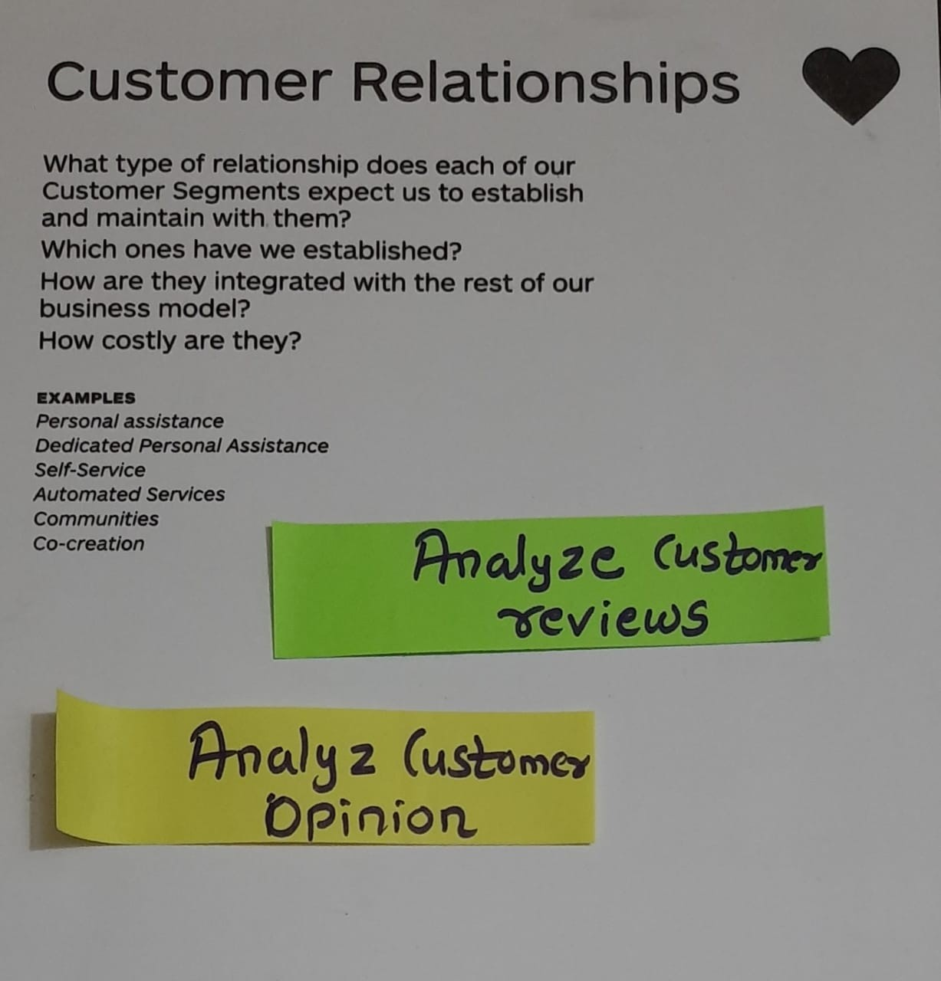

Figure VII Customer Relationship

5

1. **CUSTOMER SEGMENT**

In this section, customers are bifurcate according to their product usage & to which kind of customer they can sell their product.

* Data Analysts
* Large masses
* 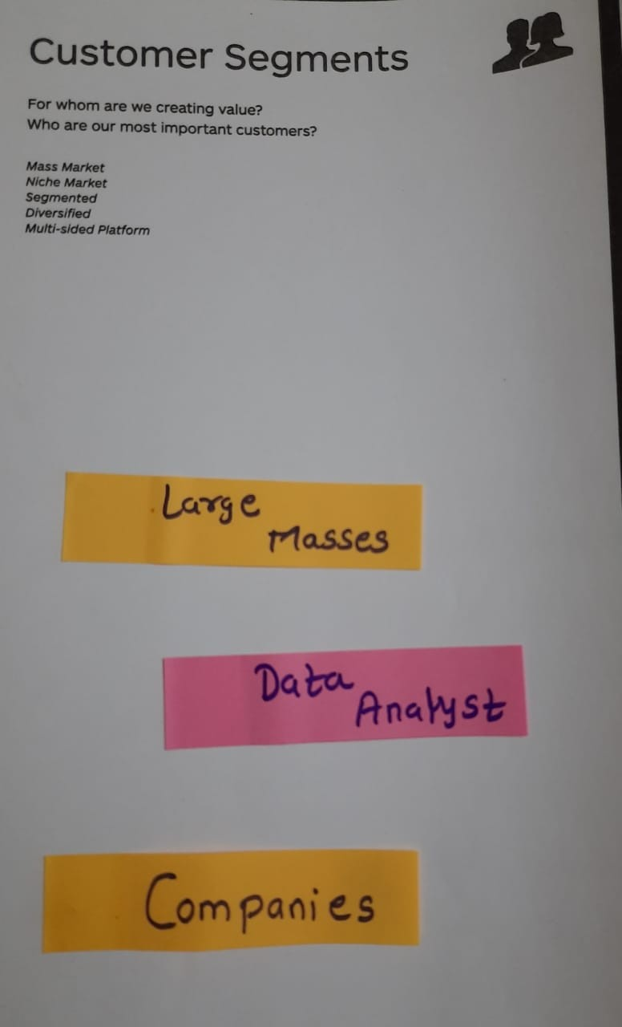Companies

Figure VIII Customer Segments

1. **CHANNEL**

In this we got to know about how they will approach customers, which media they should select for the marketing of their product.

* Website
* Data Science publications

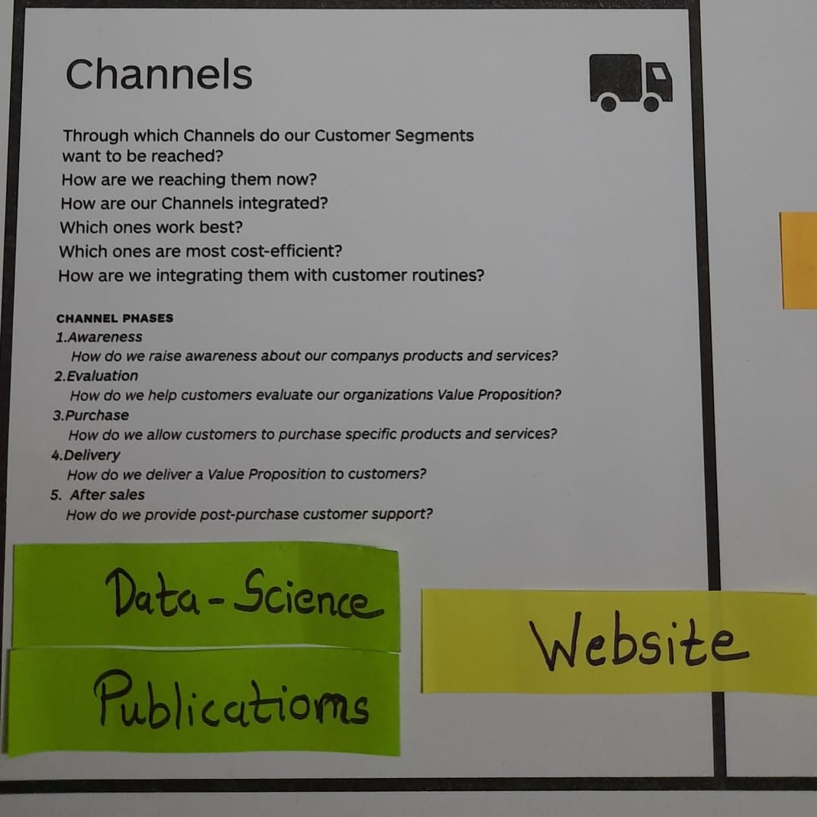

Figure IX Channel

6

1. **COST STRUCTURE**

They can attract customers towards their product by giving them lucrative offers in cost. In which department, they should have to invest most.

* Maintaining Server
* Maintenance Team

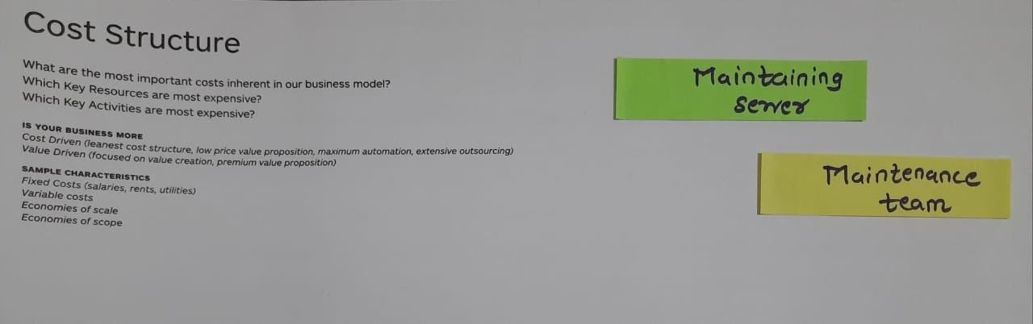

Figure IX Channel

1. **REVENUE STREAM**

* Usage free
* Subscription fee
* Licensing

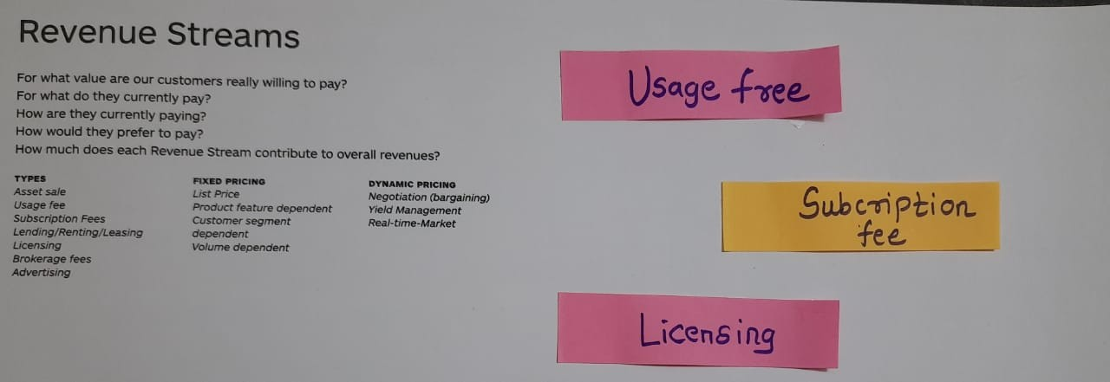

Figure XI Revenue Stream

7

**CHAPTER: 3**

**CONCLUSION**

**Conclusion:**

Business Model Canvas will be helpful to people to embark entrepreneurship. One can make a good product from their project. Increase manufacturing unit in India and enhance the economy of India.

8